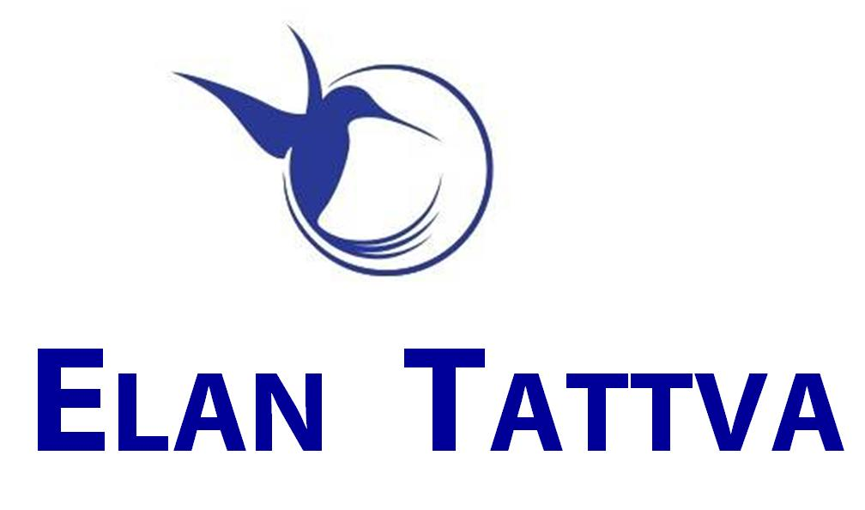



A Journey of Insights & Illumination
Set and Pursue 3 Inspiring Primary Goals
in a 12 weeks timeframe +
4 to 7 Secondary goals

Fully Self-Driven approach
The Coach is an enabling catalyst.
Get your Coach to support you as an Accountability Partner during the execution phase
Coaching Journey runs parallel to 12 weeks of the Crucial Phase of Actions/Execution of your Most Important Goals.

Coaching Processes to tackle limiting patterns/habits & ‘unresourceful’ routines
Highly Practical & Innovative Approach to Planning (with NLP Time-based techniques)
Mind Programming, Creative Visualization

Bonus (Optional):
Personal Stress Profile Analysis to identify your Stress Susceptibility Factors, Coping Strategies & Support System

Do you want these?
• Develop Power Routines to increase personal effectiveness

• A Coach’s support to maintain empowering
new habits

• Review, Refine & Polish your Daily TIME STRUCTURE & propel yourself to
desired outcomes

• STRATEGIES for Highly Effective Actions
vis-à-vis your targets

• Structured VISIONING process for your most Audacious Goals

• Learn and Use tools/frameworks such as
Vision Maps, Vision Boards, Success Network,
Locus of Control

Sign Up in Nov 2013 & Avail Attractive Rates!!!

Big Increase in Prices Planned in Dec 2013!!!
One-One EXEC Coaching

The One-One Coaching Process is typically spread out over a time-frame of 12 weeks. This is a unique opportunity to work in a
self-directed manner to develop empowering habits and routines to realize your most cherished goals.

Shift your Intentions to Power HABITs to a life of TRUE POTENTIAL

Call → 99722 97259; Email → elantattva@gmail.com; Website → http://www.elantattva.com

